

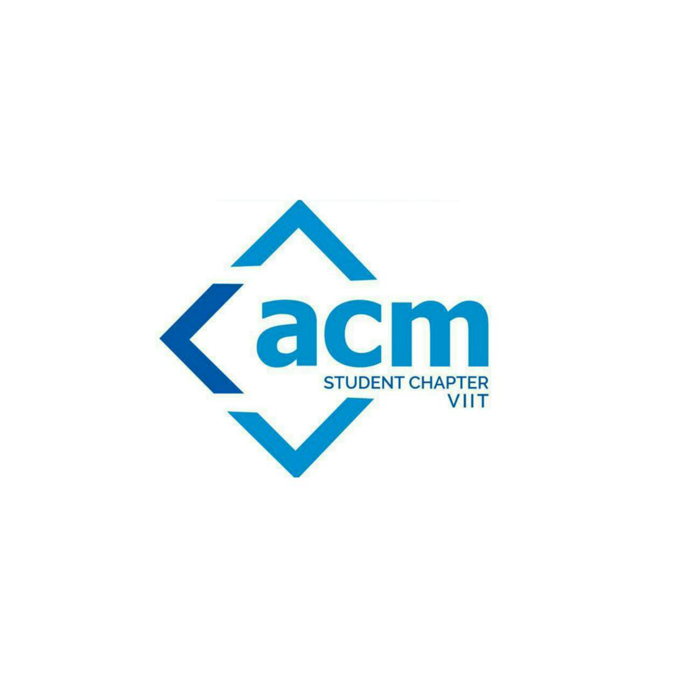





**B.R.A.C.T’S**

**Vishwakarma Institute Of Information Technology, Pune**

**Report on:** Azadi Week Day - 4, 5, 6

**Organized by**: CSI VIIT, ACM VIIT, Coding Forum VIIT

**Date, Location**: 19th, 20th , 21st August 2021, Azadi

**AZADI Contest**

The Azadi contest started on 19th August and was for 3 days with a tagline “ Try and try till you succeed…”. This contest was organized by Coding Forum VIIT, ACM VIIT & CSI VIIT. The Coding Forum was managing the contest with CSI & ACM.

On the First Day, 4 Problem statements were released that were ‘Head's Instagram Post’, ‘Minimizer Mukesh’, ‘gold_medalist’ & ‘Array Sum’. The maximum number of submissions were for ‘Array Sum’ which was 28 with a success rate 78.57%. The most difficult and lowest success rate problem statement was ‘gold_medalist’ which was 31.25% & the problem statement with highest success rate was ‘Minimizer Mukesh’ which was 87.50%.

On the 2nd day, 4 more Problem statements were released that were ‘Number Pattern’, ‘Required Matrix’, ‘Rich Villagers’ & ‘Coding Forum Interview’. The maximum number of submissions were for ‘Required Matrix’ which was 18 with a success rate 100% the highest for the day. The most difficult and lowest success rate problem statement was ‘Coding Forum Interview’ which was 50%.

On the 3rd and the last day of the Azadi contest, 4 more Problem statements were released that were ‘no. of triplets’, ‘Chef's different game’, ‘Assignment Help’ & ‘Karan's Sum’. The maximum number of submissions were for ‘Chef's different game’ which was 16 with a success rate 87.50% the highest for the day. The most difficult and lowest success rate problem statement was ‘Karan's Sum’ which was 50%.

The whole contest was a big success with some difficult, some easy and some medium level problem statements.